Template document status – do not change
Version | 2.0
Date | 09/2022
Status | Released
Classification | Restricted
Template document responsible | Lindenthal, Karlheinz  Lamberty, Andrea

Important notes:
Test responsible:
In the IT Requirement (ITR) process the user acceptance test is in responsibility of the Requester/Key User. For the internal integration test as part of a bug fix (Change request) the test is in responsibility of the Application Analyst.
Test result:
The test result must be recognizable.
Screenshots:
All screenshots must have an IPE-compliant display which means that date, time and the SAP System/Client must be included in every screenshot.
Naming Convention:
Name of the test document should start with SX_ followed by the ticket number of the change document. Optionally the document type UAT (FTC) can be added, e.g. S_UAT_4100002725_testdocument. – to be revised with the completion of the SHERPA X transition
Reference ticket number:
For internal integration test please use the number of the change document (e.g. normal change) as the reference ticket. The user acceptance test should refer to the respective IT Requirement.

Test document history – please fill
Title / Filename
Date | Version | Short description |  | Created by
19.10.2025 | 1 | CUT-27101 - Maintain OCI punchout parameters |  | Ajit Gautam
DD/MM/YYYY | Version | Description |  | Name
DD/MM/YYYY | Version | Description |  | Name
DD/MM/YYYY | Version | Description |  | Name
DD/MM/YYYY | Version | Description |  | Name
DD/MM/YYYY | Version | Description |  | Name

Cutover Task Details: Maintain OCI Parameters (Link, Key & Logical system) for all P2R units
Date of test | 19.10.2025
Name and department of tester | P2R Ajit Gautam
System | ☐ DEV | ☐ QA | ☒ PROD
Reference ticket number

Testcase
Describe shortly the test case and the expected results / purpose of the test
Maintain OCI Parameters (Link, Key & Logical system) for all P2R units

Unit Scope is below :

DIR / IND / DIR SRE | Company Name | ARE | Company Code | Purchasing Org
IND | Siemens Mobility A/S | 526W | 3012 | 0003
IND | SIMEA SIBIU S.R.L. (Sibiu) | 539D | 3014 | C501
DIR SRE | SIMEA SIBIU S.R.L. (Sibiu) | 539D | 3014 | C501
IND | Siemens Financial Services GmbH | 5026 | 5026 | A200
IND | Siemens Project Ventures GmbH | 5089 | 5089 | AP00
IND | Siemens Bank GmbH | 524K | 524K | AR00
IND | Siemens Bank GmbH, London Branch | 556P | 556P | AT00
IND | Siemens Technology and Services Private Limited | 5663 | 3368 | CT00
DIR SRE | Siemens Technology and Services Private Limited | 5663 | 3368 | CT00
IND | Siemens Advanta Solutions GmbH | 562K | 562K | AH00
IND | evosoft GmbH | 581C | 581C | AG00
IND | Siemens AG - SRE Headquarters, München | 7998 | 7998 | BY00
DIR SRE | S'Ind.park Karlsr. | 4001 | 3371 | CE00
DIR SRE | SMOREM KG​ | 442Q | 3372 | CF00
DIR SRE | IPDG KG​ | 452C | 3373 | CG00
DIR SRE | CAPTA Grst Verw GmbH | 561C | 3374 | CK00
DIR SRE | SCE Objekt 3 KG​ | 573K | 3375 | CL00
DIR SRE | SCE Objekt 4 KG​ | 574K | 3376 | CM00
DIR SRE | SCE Objekt 5 KG​ | 575K | 3377 | CN00
DIR SRE | SCE Objekt 6 KG​ | 576K | 3378 | CO00
DIR SRE | SCE Objekt 7 KG​ | 577K | 3379 | CP00
DIR SRE | SCE Verwaltungs GmbH​ | 578K | 3380 | CQ00
DIR SRE | SCE Grundstücks KG​ | 579K | 3381 | CR00
DIR SRE | SCE Objekt GmbH | 580K | 3382 | CS00
DIR SRE | Berliner Vermögensverw | 5035 | 3384 | CH00
DIR SRE | Geisenhausener Entw. KG | 523Q | 3385 | CI00
DIR SRE | Moorenbrunn Entw. KG | 524Q | 3386 | CJ00

Update below parameters for all units accordingly:

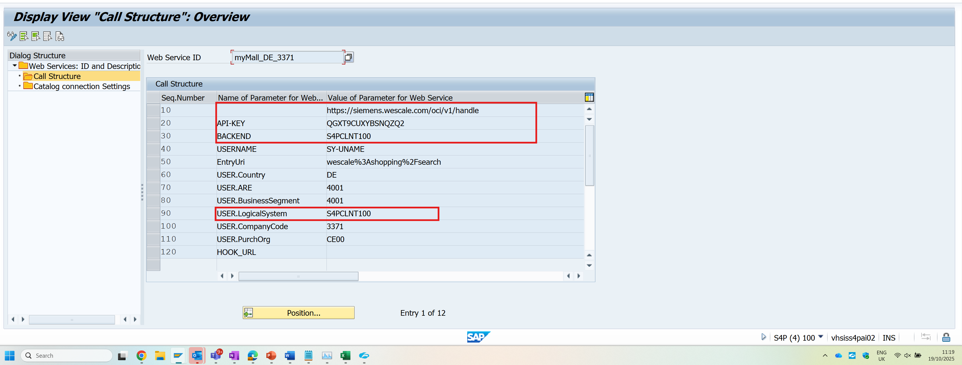

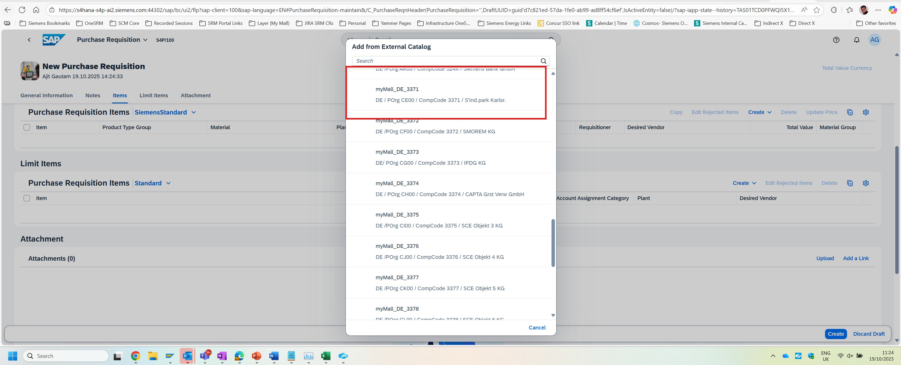

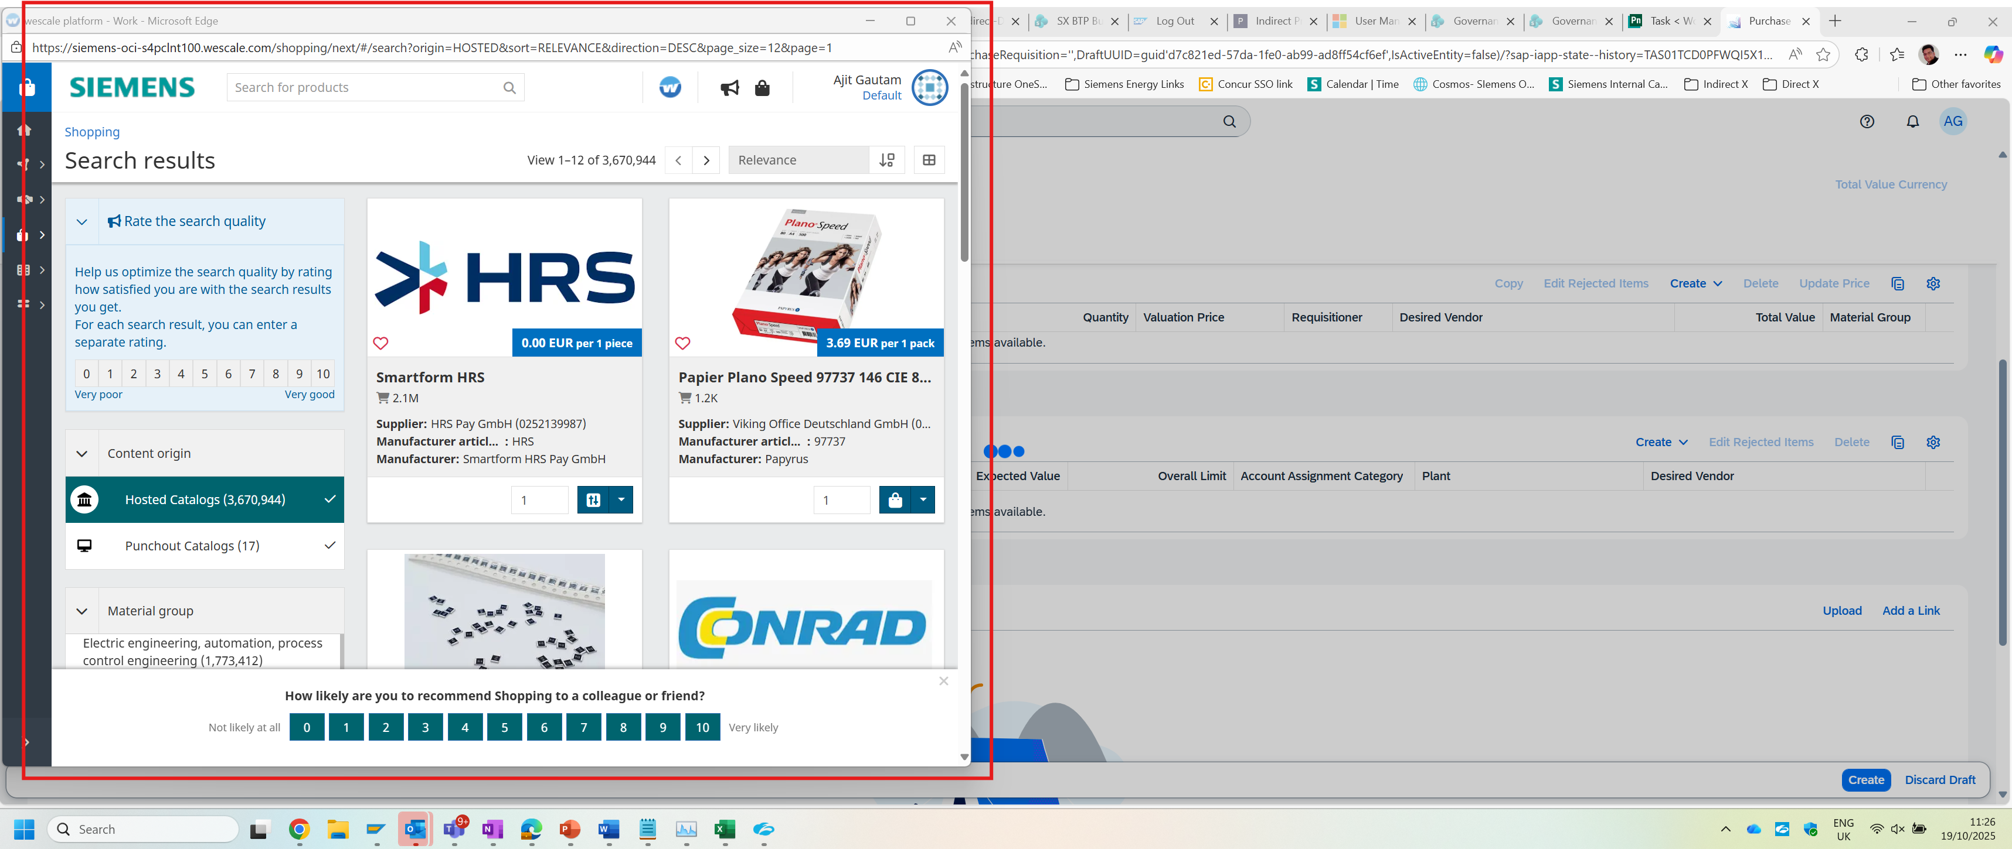

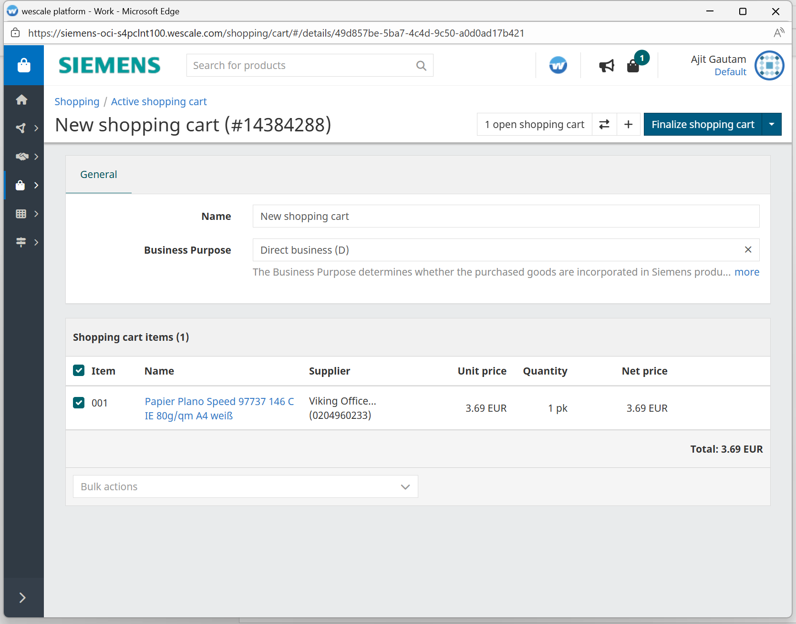

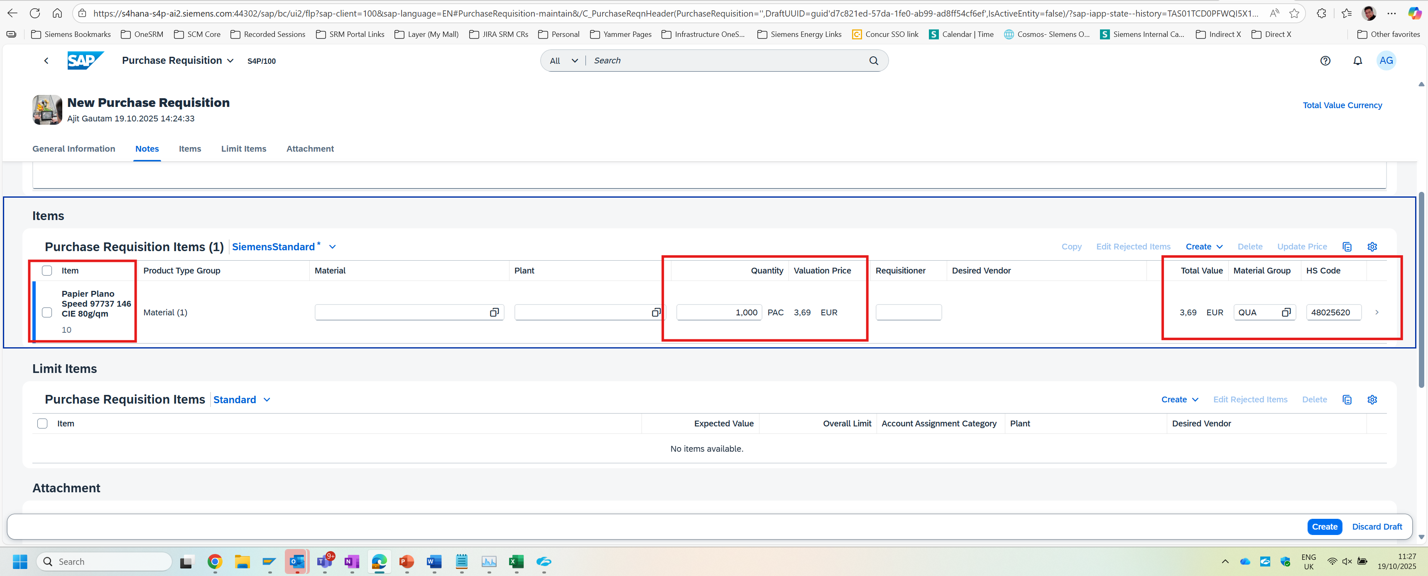

Screenshots of test, error messages, comments, test result & output
Test was successful  Please attach a screenshot of the result and of any documents output. | ☒
Test was not successful  Please attach a screenshot of the result and any error messages.  Consider a new test. Test document should be enhanced by another test case. | ☐

